118A1084

**EXPERIMENT 4**

Drop table employee

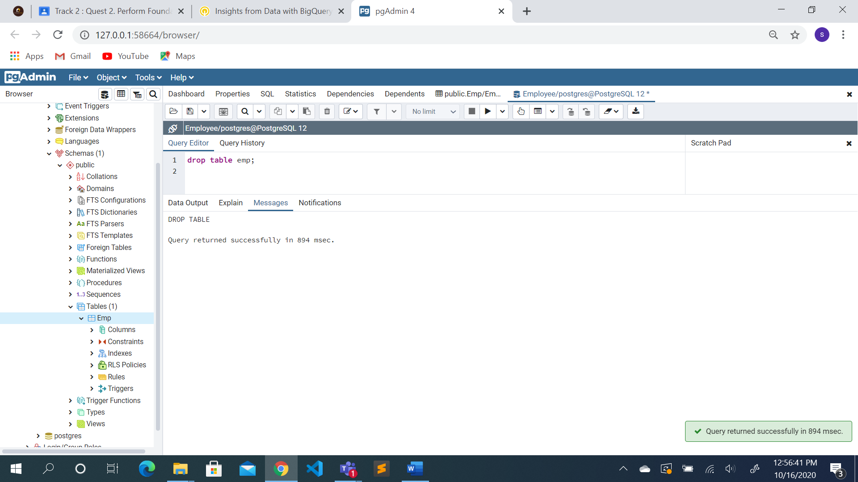

create table employee(emp_id CHAR(5) PRIMARY KEY,emp_name varchar(15),job_name varchar(10),manager_id CHAR(5),hire_date date ,salary int,comm int,deptid char(4));

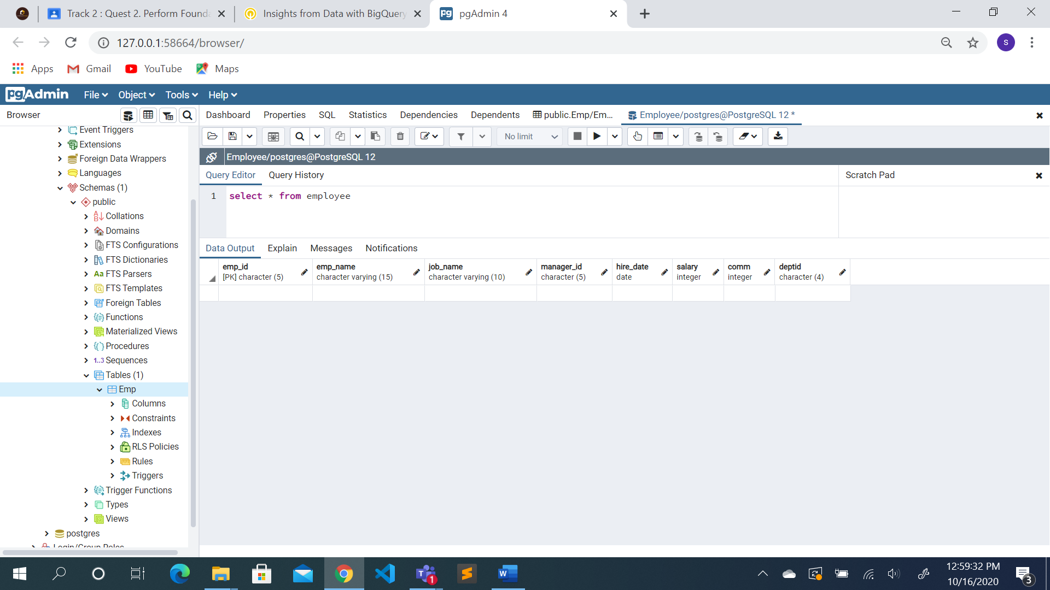

insert into employee values ('66928','BLAZE','MANAGER','68319','1991-05-01',2750,0,'3001')

insert into employee values ('67832','CLARE','MANAGER','68319','1991-06-09',2550,0,'1001')

insert into employee values ('65646','JONAS','MANAGER','68319','1991-04-02',2957,0,'2001')

insert into employee values ('64989','ADELYN','SALESMAN','66928','1991-02-20',1700,400,'3001')

insert into employee values ('65271','WADE','SALESMAN','66928','1991-09-28',1350,600,'3001');

insert into employee values ('66564','MADDAN','SALESMAN','66928','1991-09-08',1600,0,'3001');

insert into employee values ('68454','TUCKER','SALESMAN','66928','1991-02-22',1600,0,'3001');

SELECT* FROM EMPLOYEE

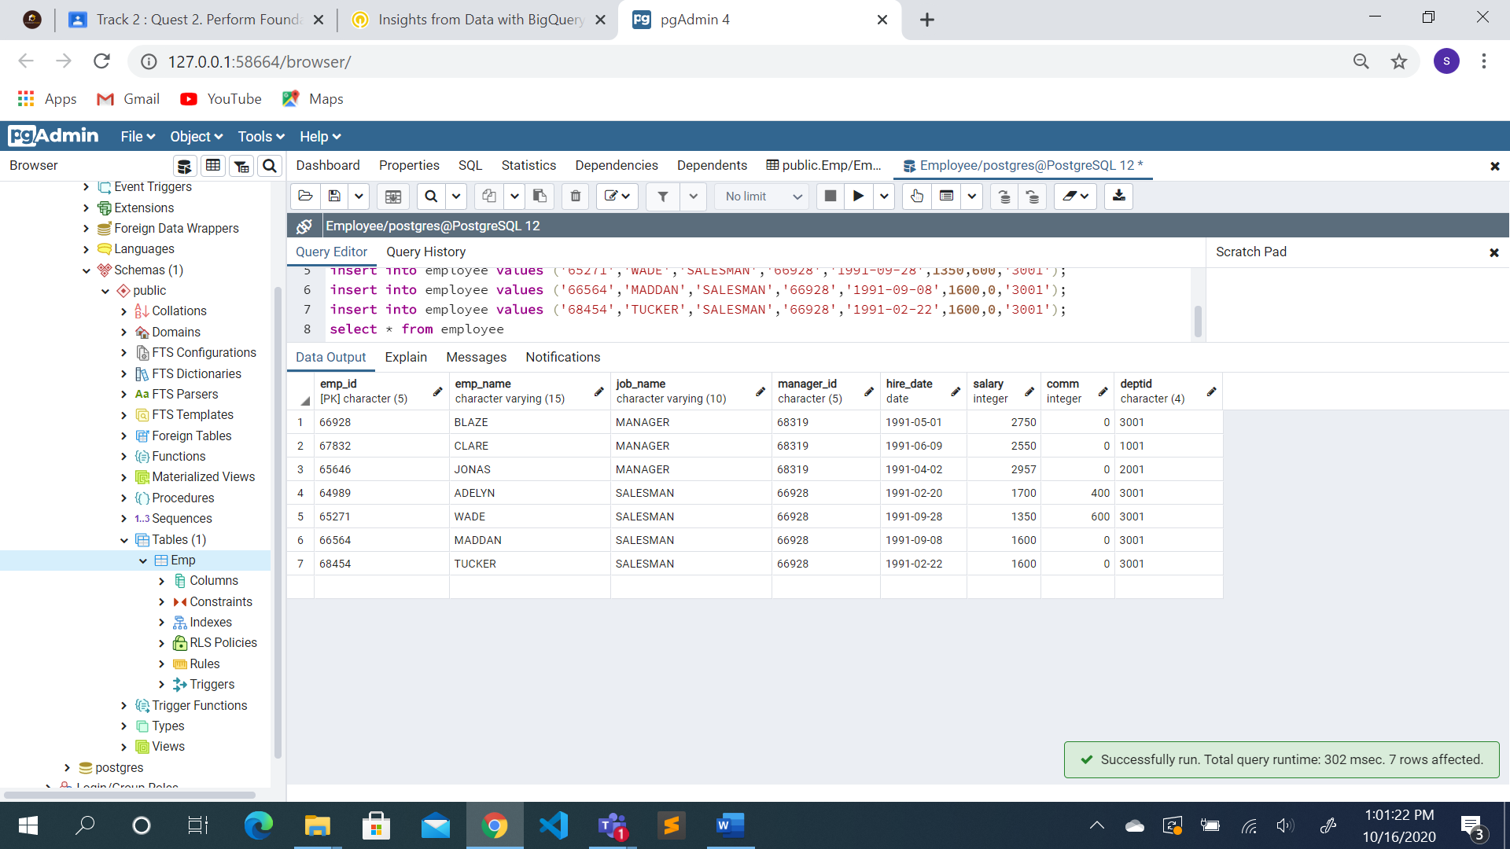

insert into employee values ('68736','ADNRES','CLERK','67858','1997-05-23',1200,0,'2001');

insert into employee values ('69000','JULIUS','CLERK','67858','1997-05-23',1200,0,'2001');

insert into employee values ('69324','MARKER','CLERK','67832','1992-01-23',1400,0,'1001');

insert into employee values ('67858','SCARLET','ANALYST','65646','1997-04-19',3100,0,'2001');

insert into employee values ('69062','FRANK','ANALYST','65646','1991-12-03',3100,0,'2001');

insert into employee values ('63679','SANDRINE','CLERK','69062','1990-12-18',900,0,'2001');

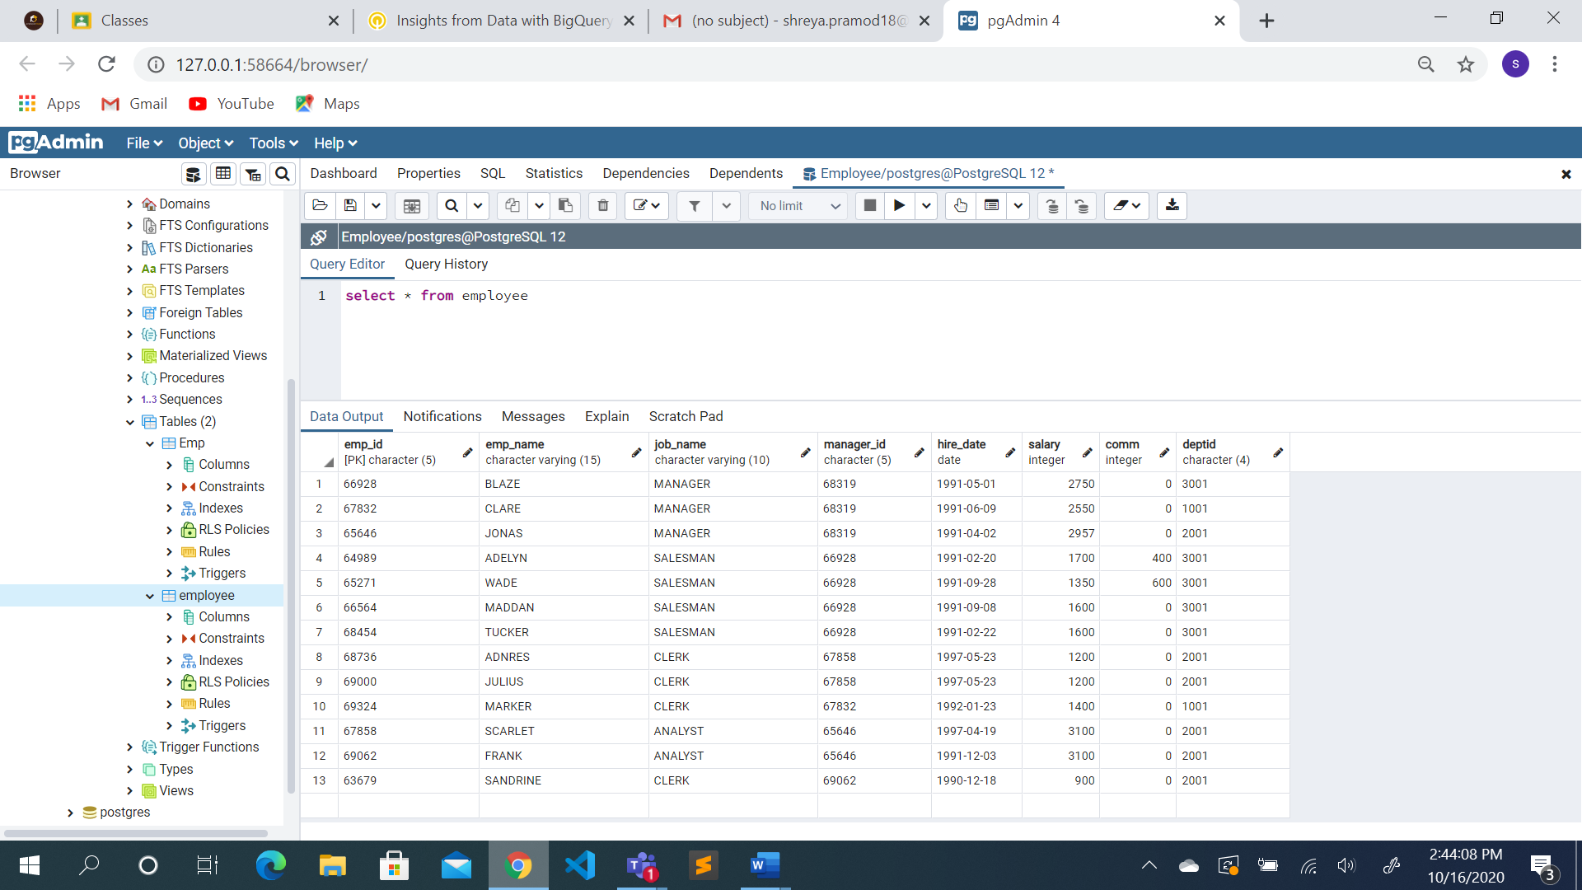

Write following queries:

1. Select the name and salary of all employees whose salary is between 2000 and 3000.

**select emp_name,salary from employee where (salary>=2000 and salary<=3000);**

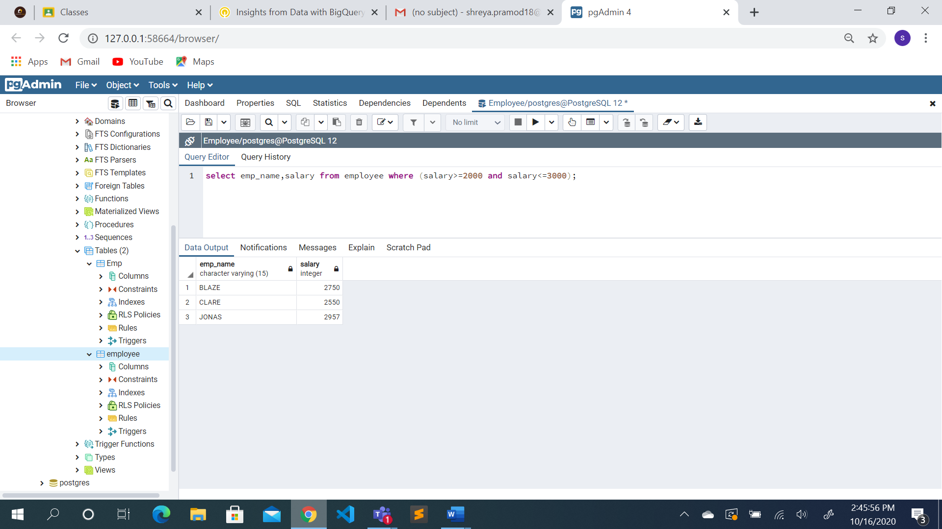

1. Select the name and salary of all employees whose Hire date is between 1st Jan 92 and 31st Dec 97

**select emp_name,salary from employee where (hire_date>='1992-01-01' and hire_date<='1997-12-31');**

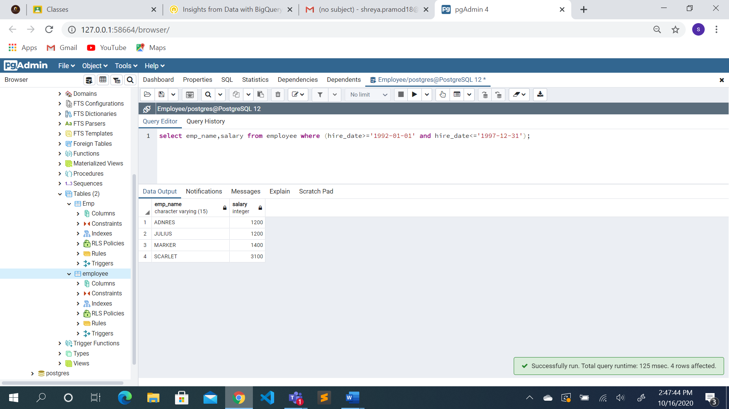

1. Select the name of all employees who work in dept 1001or 2001

**select emp_name from employee where (deptid='1001' or deptid='2001');**

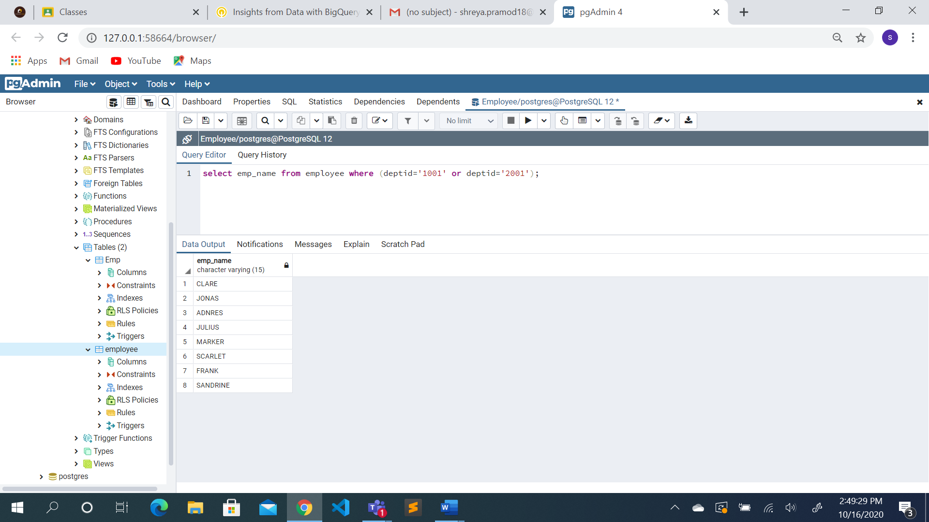

1. Select the name of all employees whose commission is 0.

**select emp_name from employee where (comm=0)**

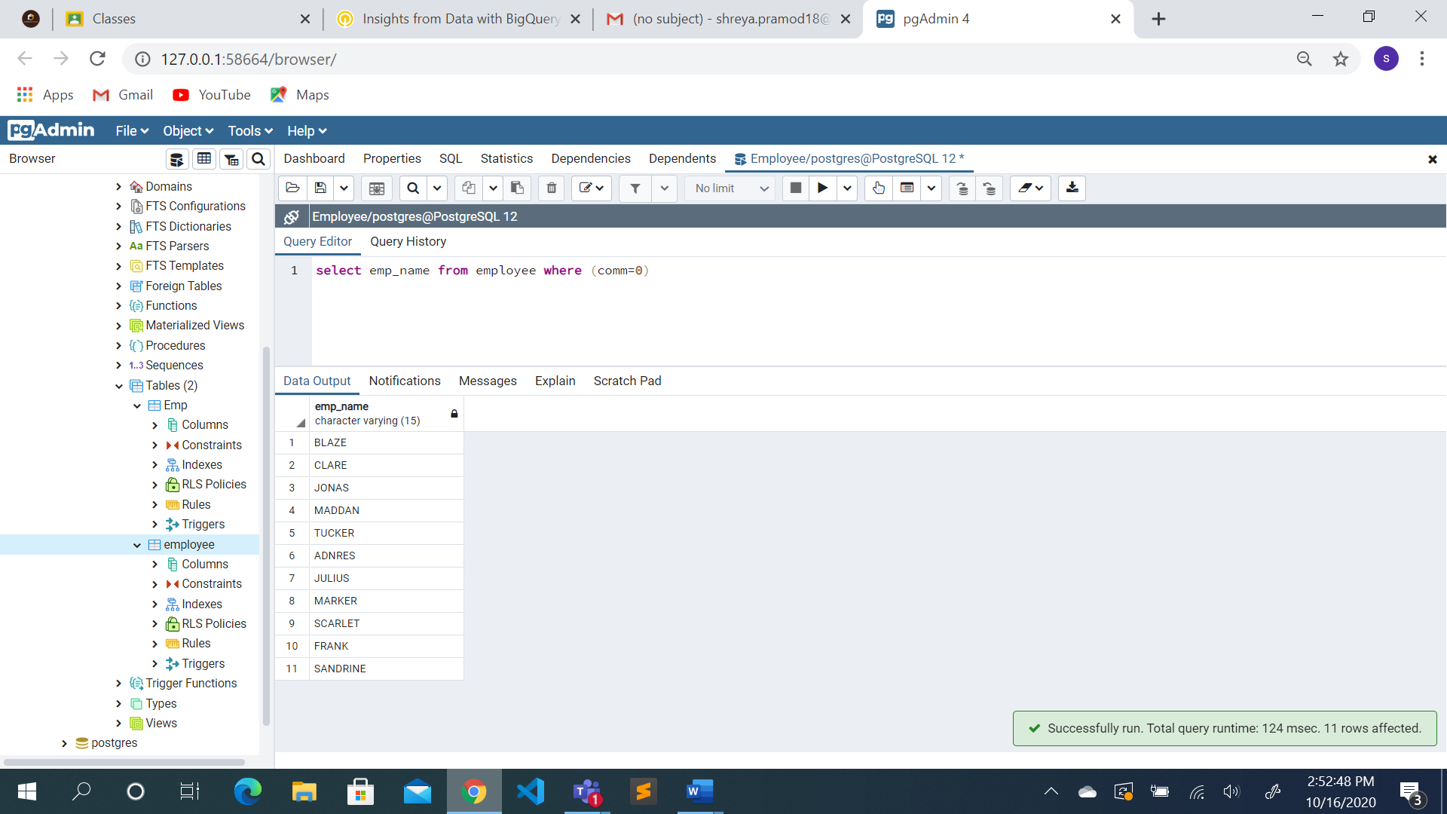

1. Select the name of all employees who are hired after 1st sep 1992 from dept 1001

**select emp_name from employee where (hire_date>='1992-09-01' and deptid='1001')**

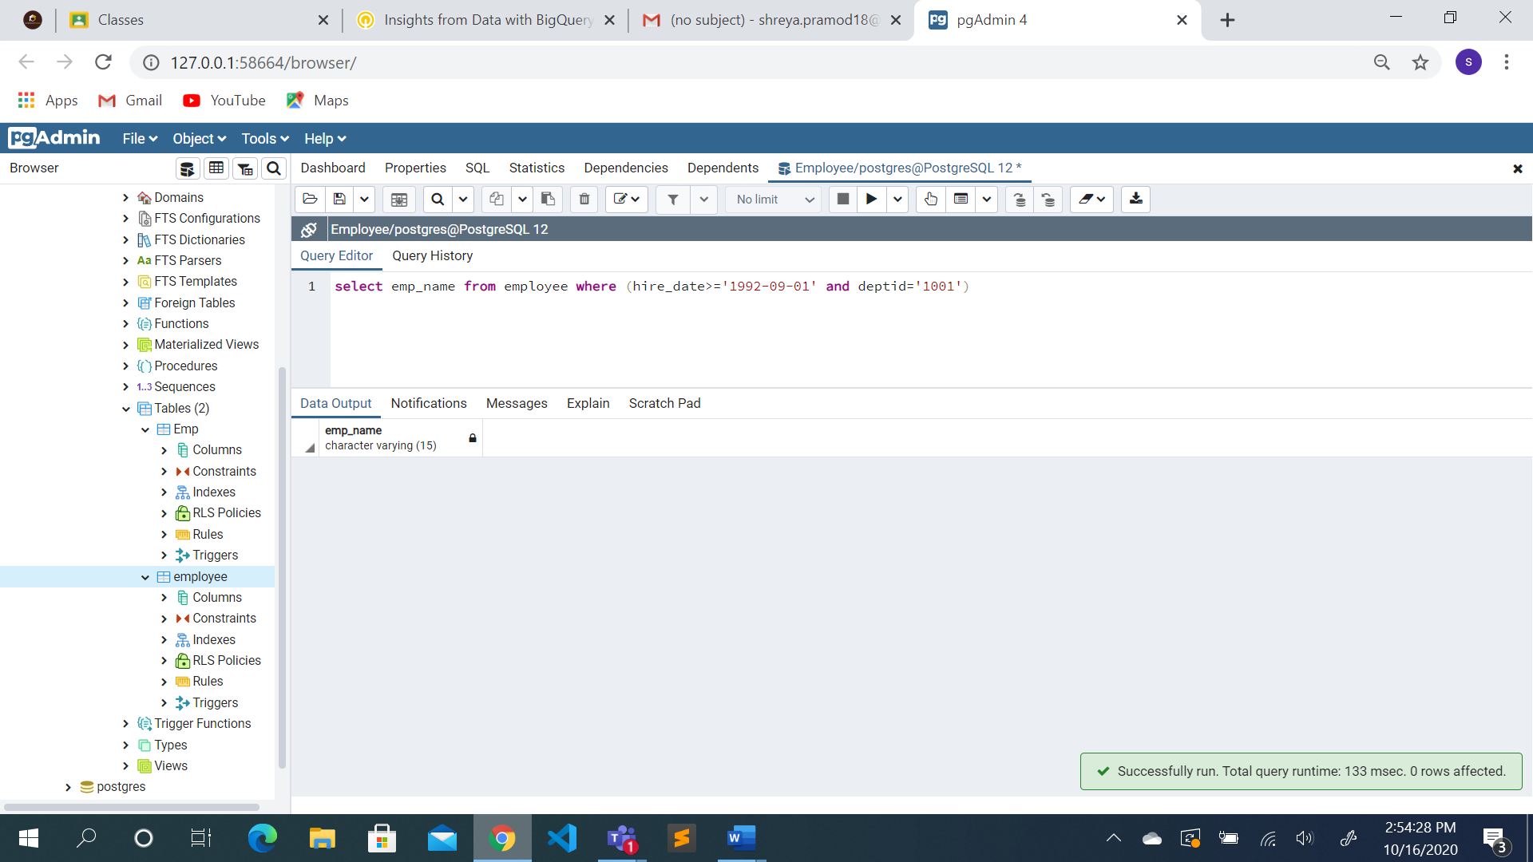

1. Select the name of all employees who do not belong to dept 1001

**select emp_name from employee where (deptid!='1001')**

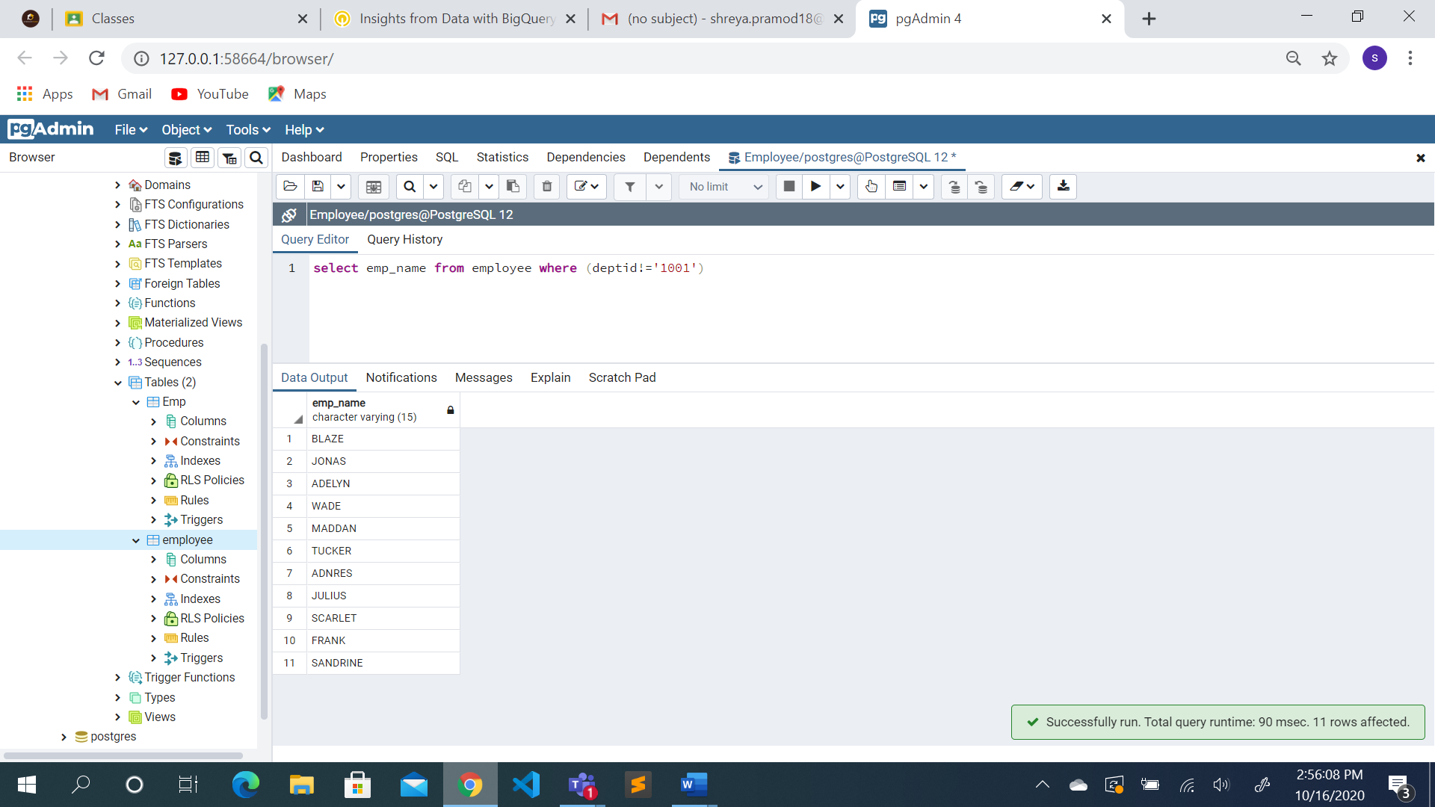

1. count the no of employees

**select count(*) from employee**

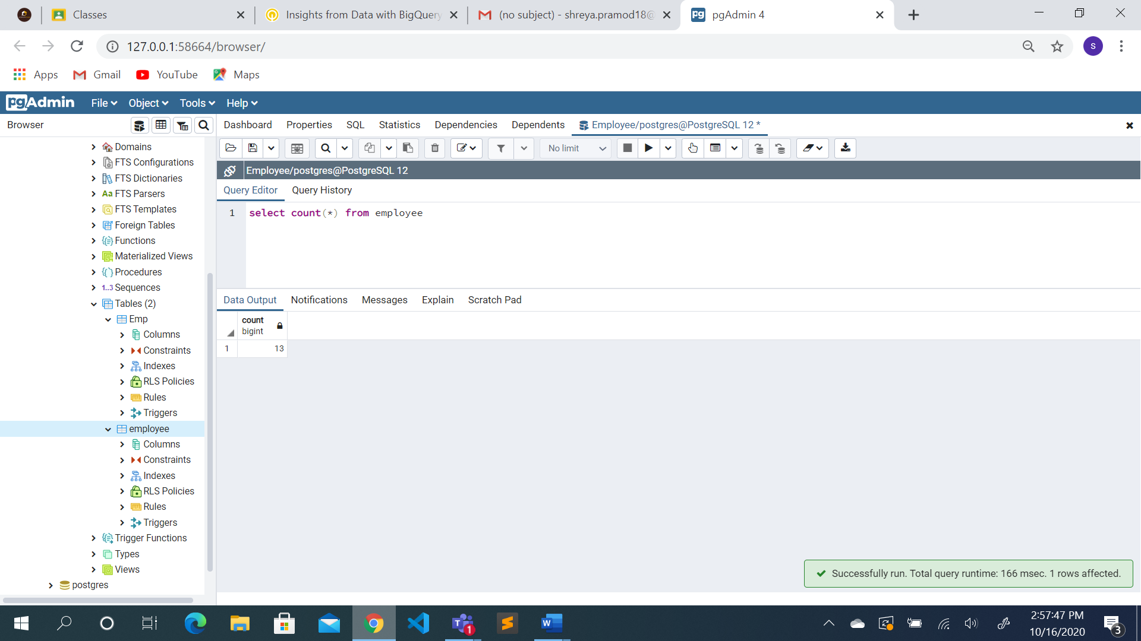

1. count the no of employees hired after 13th Jan 1997

**select count(*) from employee where (hire_date>='1997-01-13')**

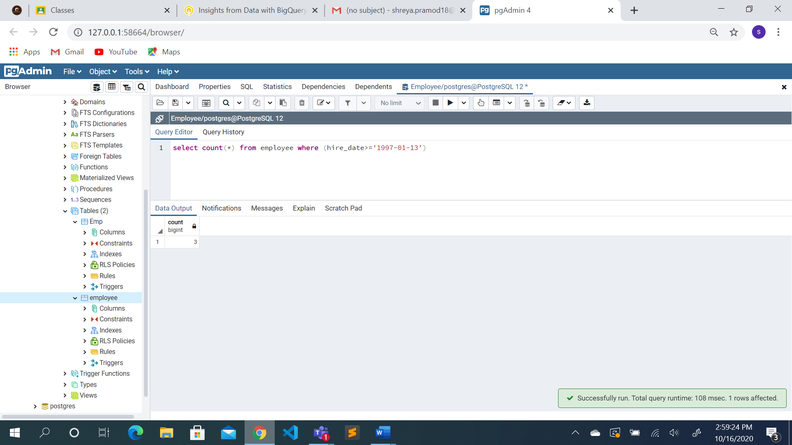

1. calculate the sum of salaries of all employees

**select sum(salary) from employee**

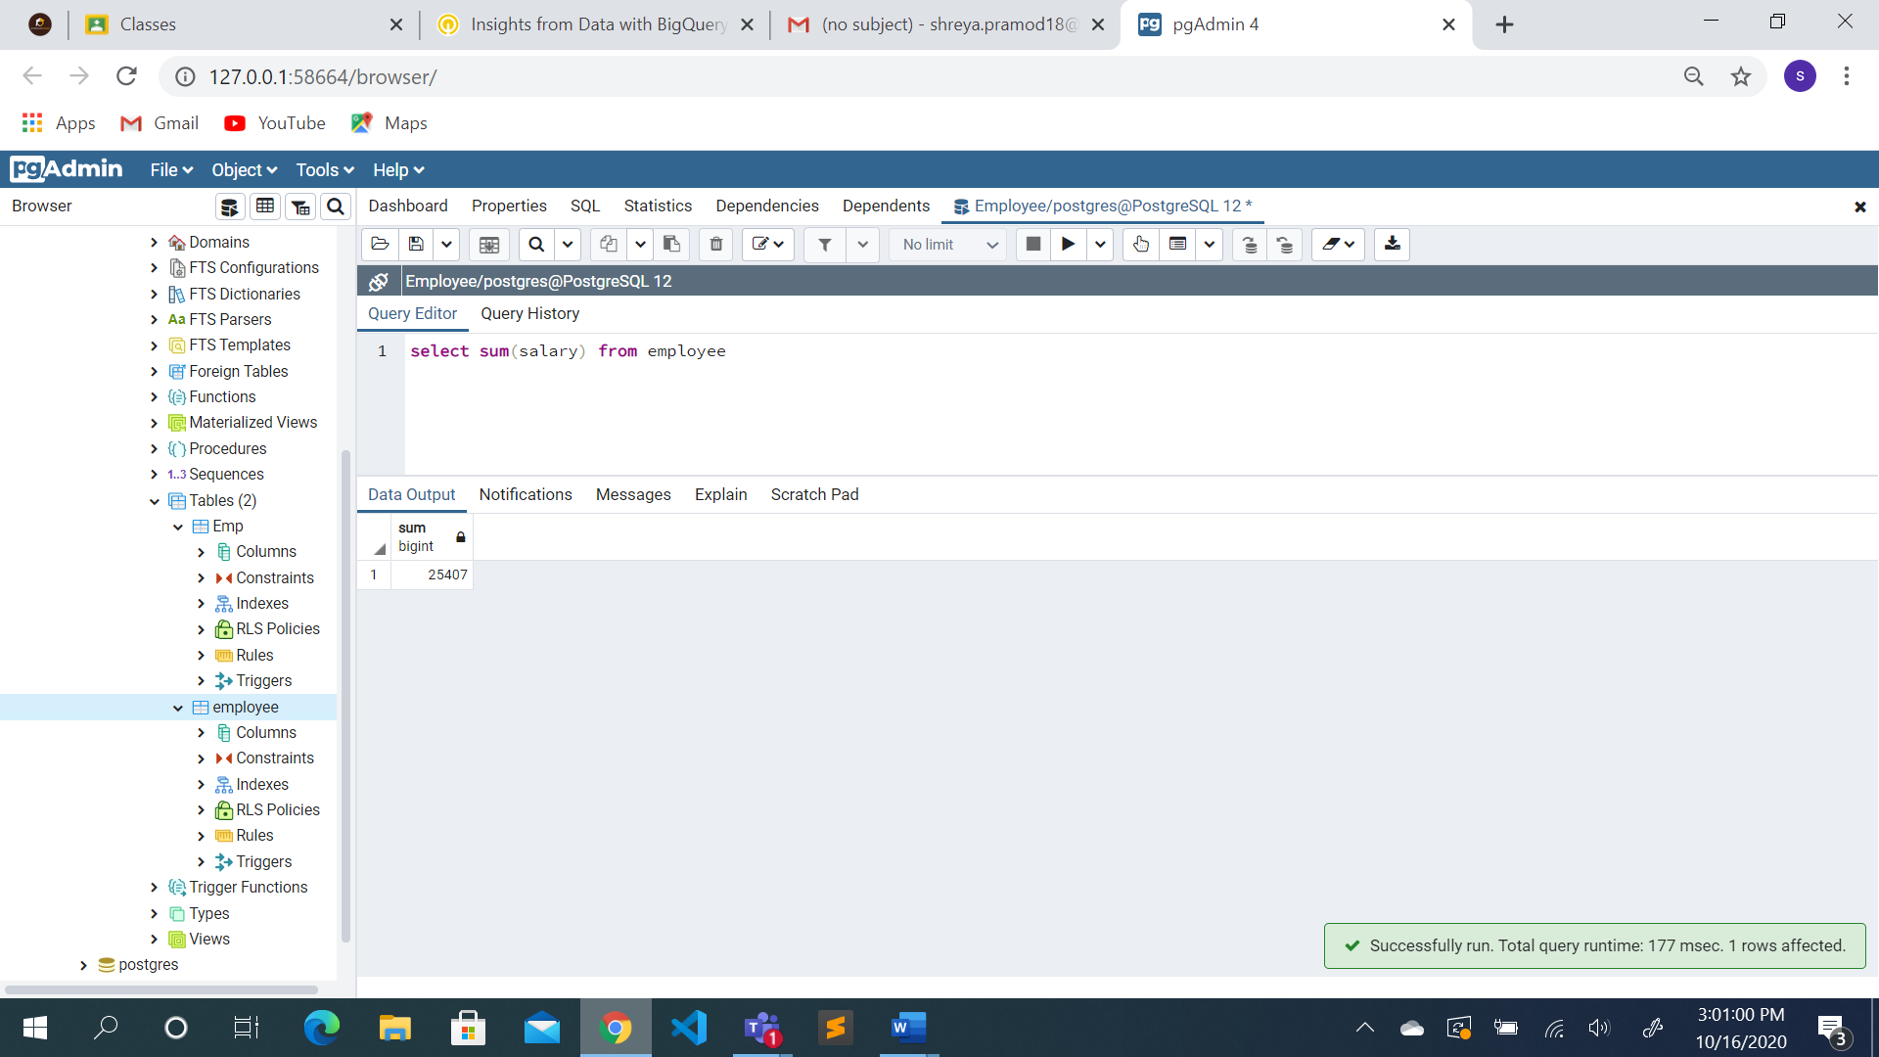

1. calculate the average of salaries of all employees

**select avg(salary) from employee**

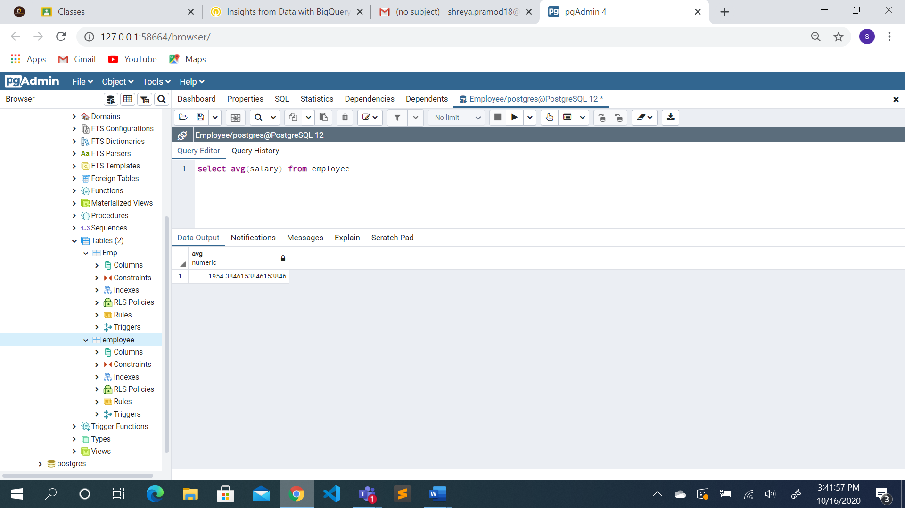

1. Get the average,minimum,maximum salary of employees for each dept

**select deptid,avg(salary),min(salary),max(salary) from employee group by(deptid)**

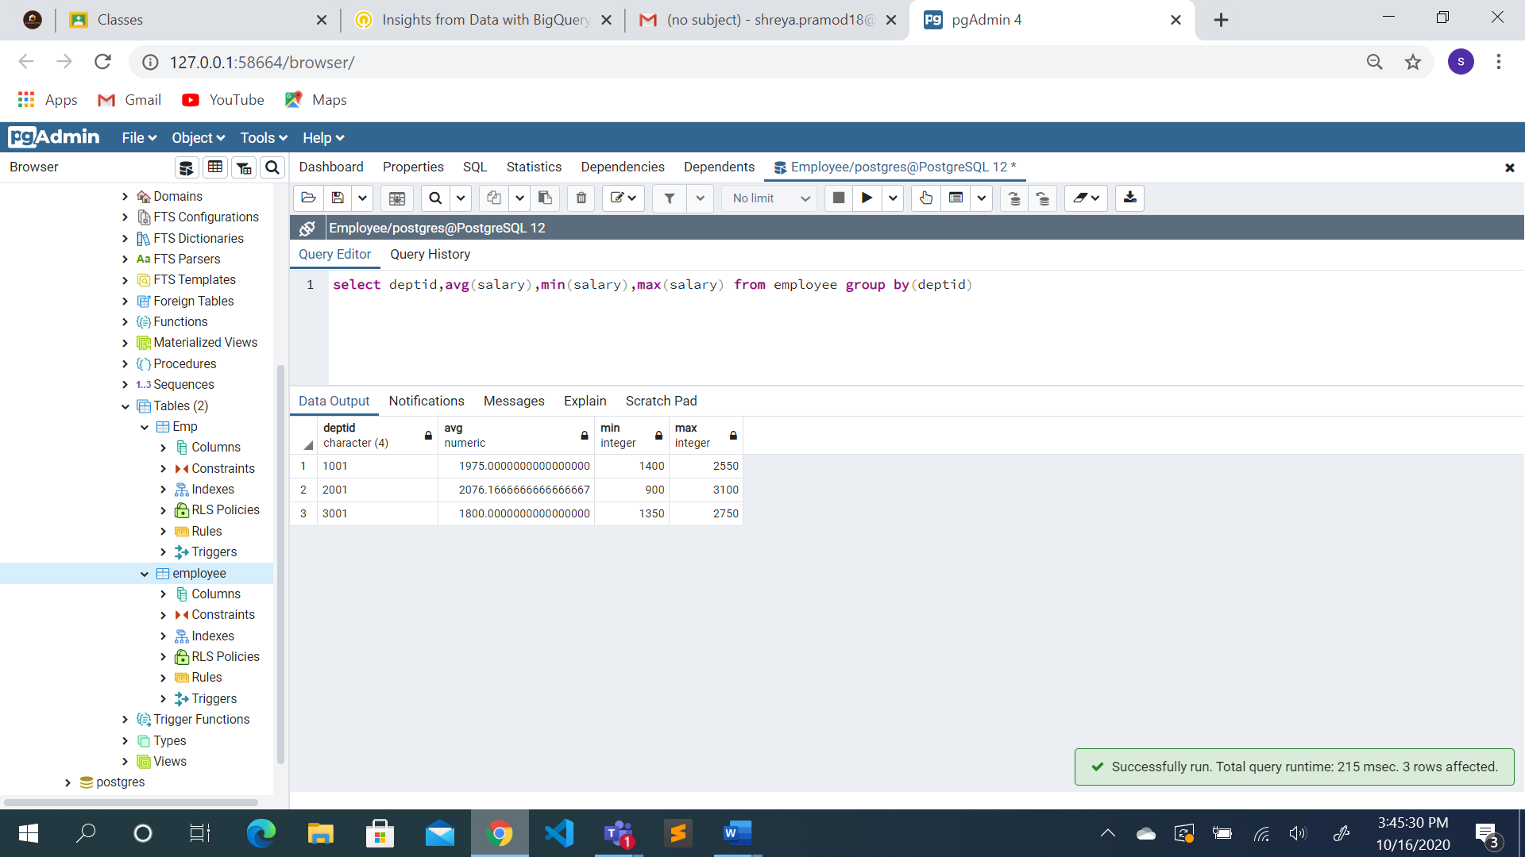

1. Get the average, minimum, maximum salary of employees for each dept having

average salary >2000

**select deptid,avg(salary),min(salary),max(salary) from employee group by(deptid) having (avg(salary)>2000)**

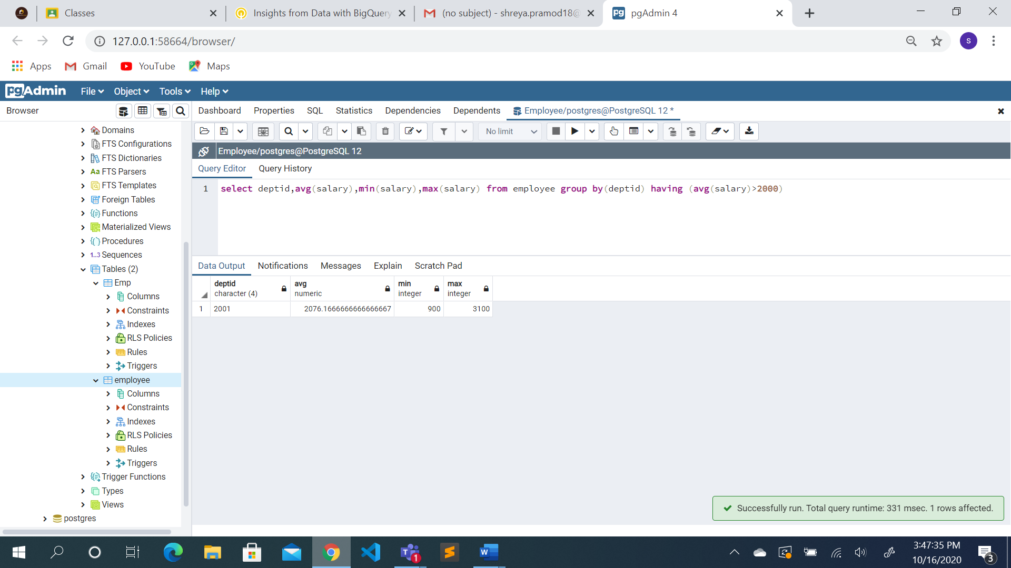

1. Get the minimum salary of employees for each job

**select job_name,min(salary) from employee group by job_name**

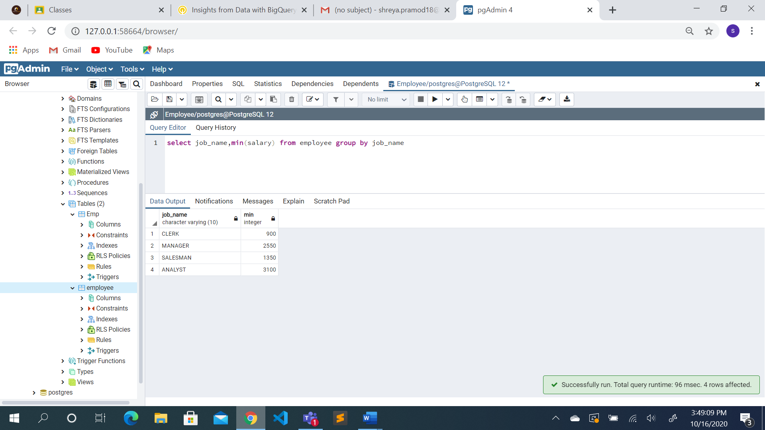

1. For each dept Get the minimum salary of employees who are clerk.

**select deptid,min(salary) from employee where (job_name='clerk') group by(deptid)**

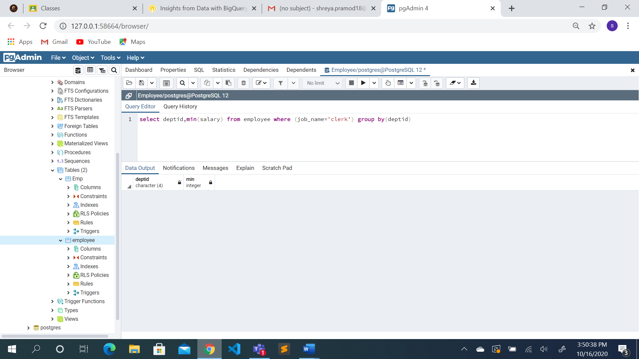

1. Get the minimum and maximum salary of employees for jobs in each dept.

**select deptid,job_name,max(salary),min(salary) from employee group by(deptid,job_name)**

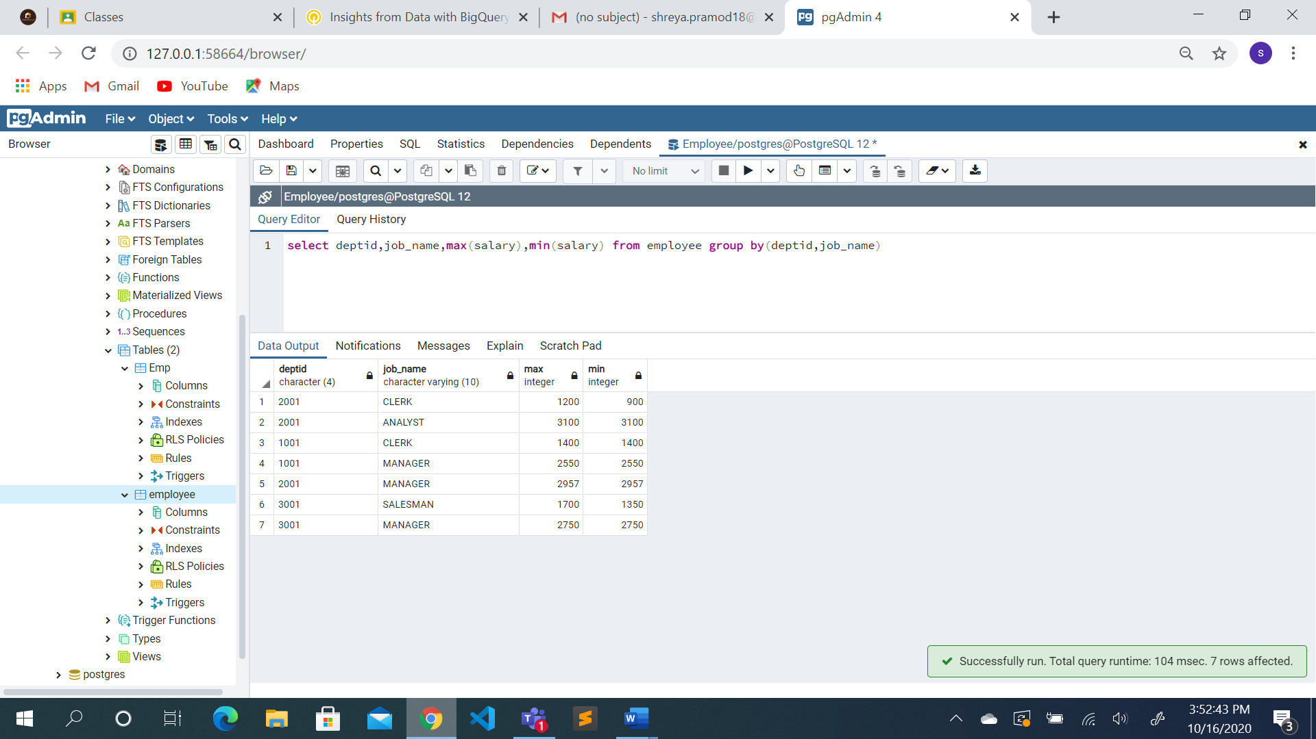

1. Get the number of available job opportunities

**select count(distinct job_name) from employee**

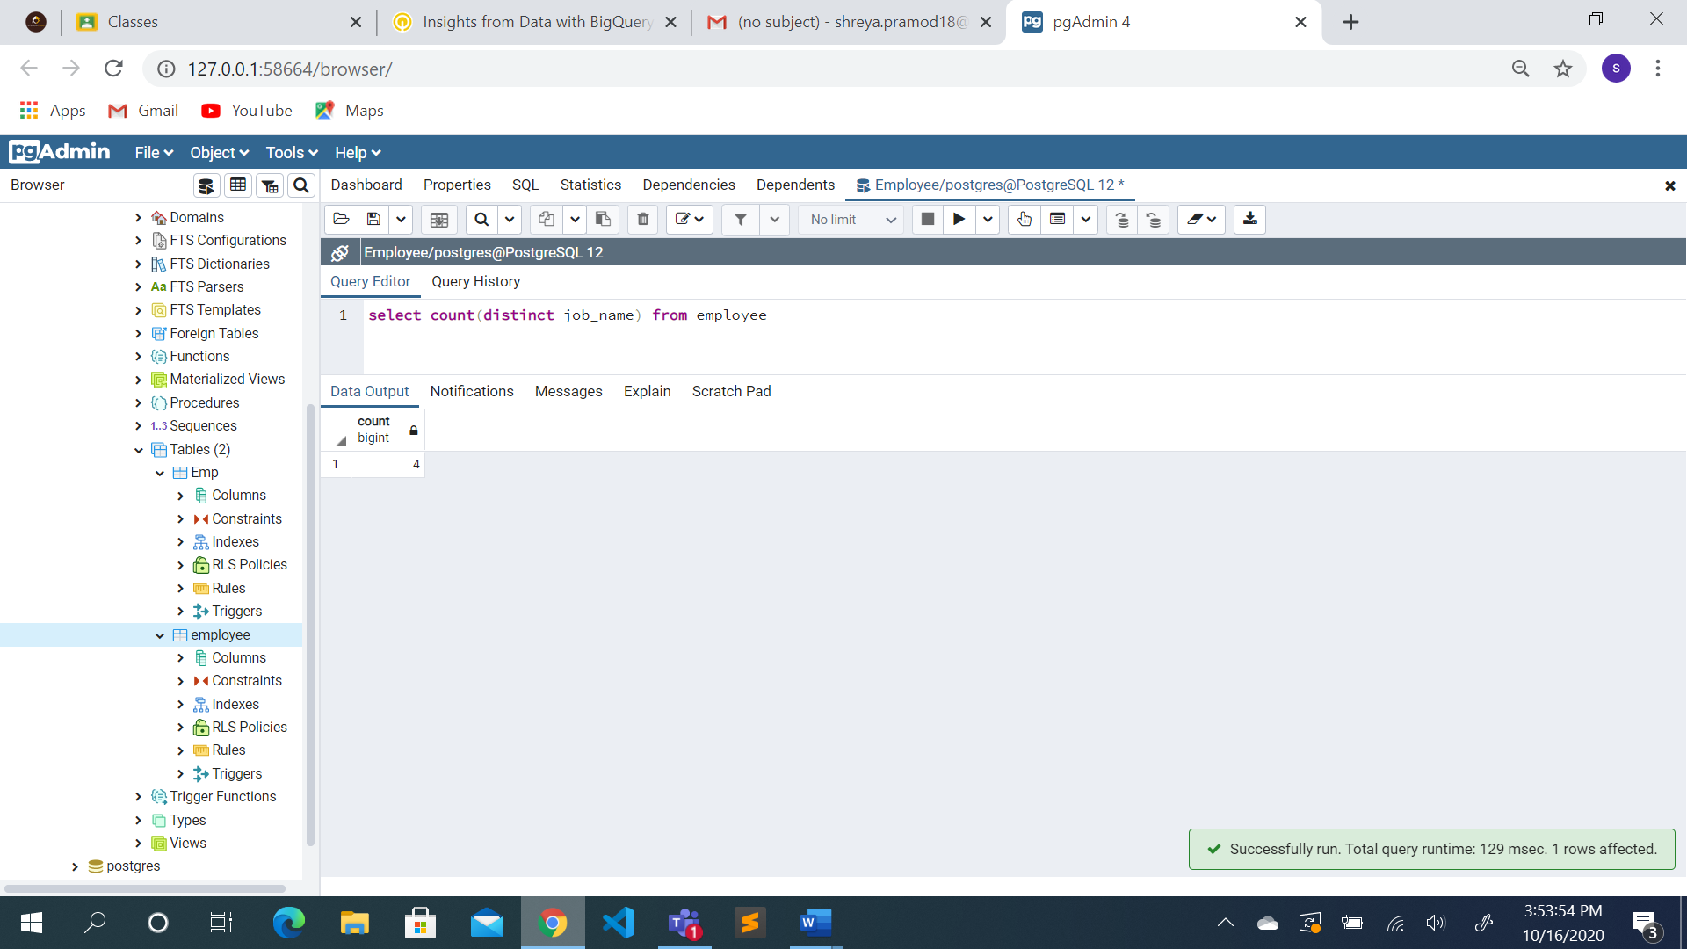

1. calculate 12 times the average salary

**select 12*avg(salary) as PRODUCT from employee**

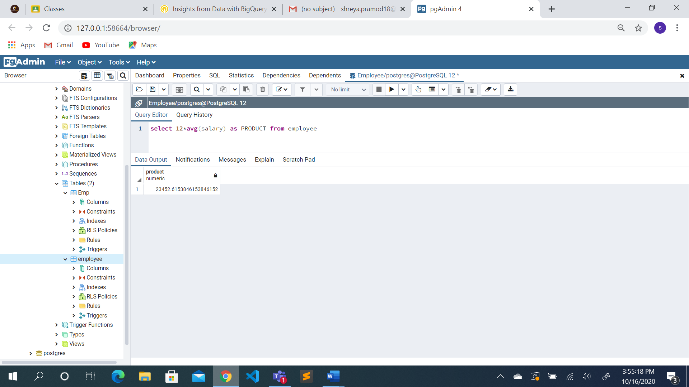

1. Get the number of employees in each department

**select job_name,count(deptid) from employee group by(job_name)**

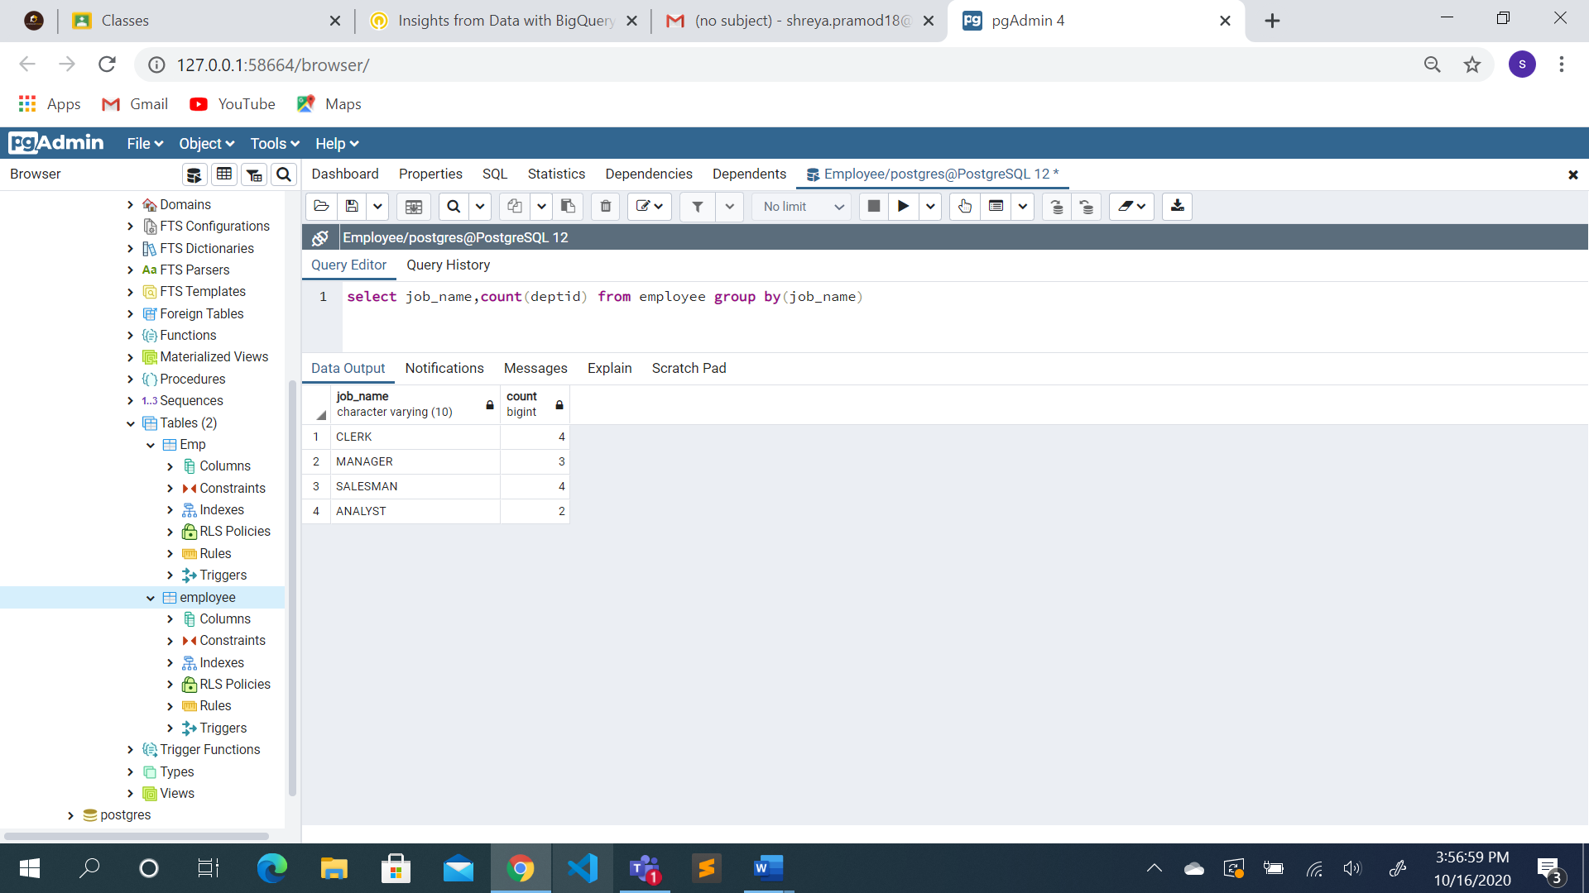

1. Get the total salary for each department.

**select deptid,sum(salary) from employee group by(deptid)**

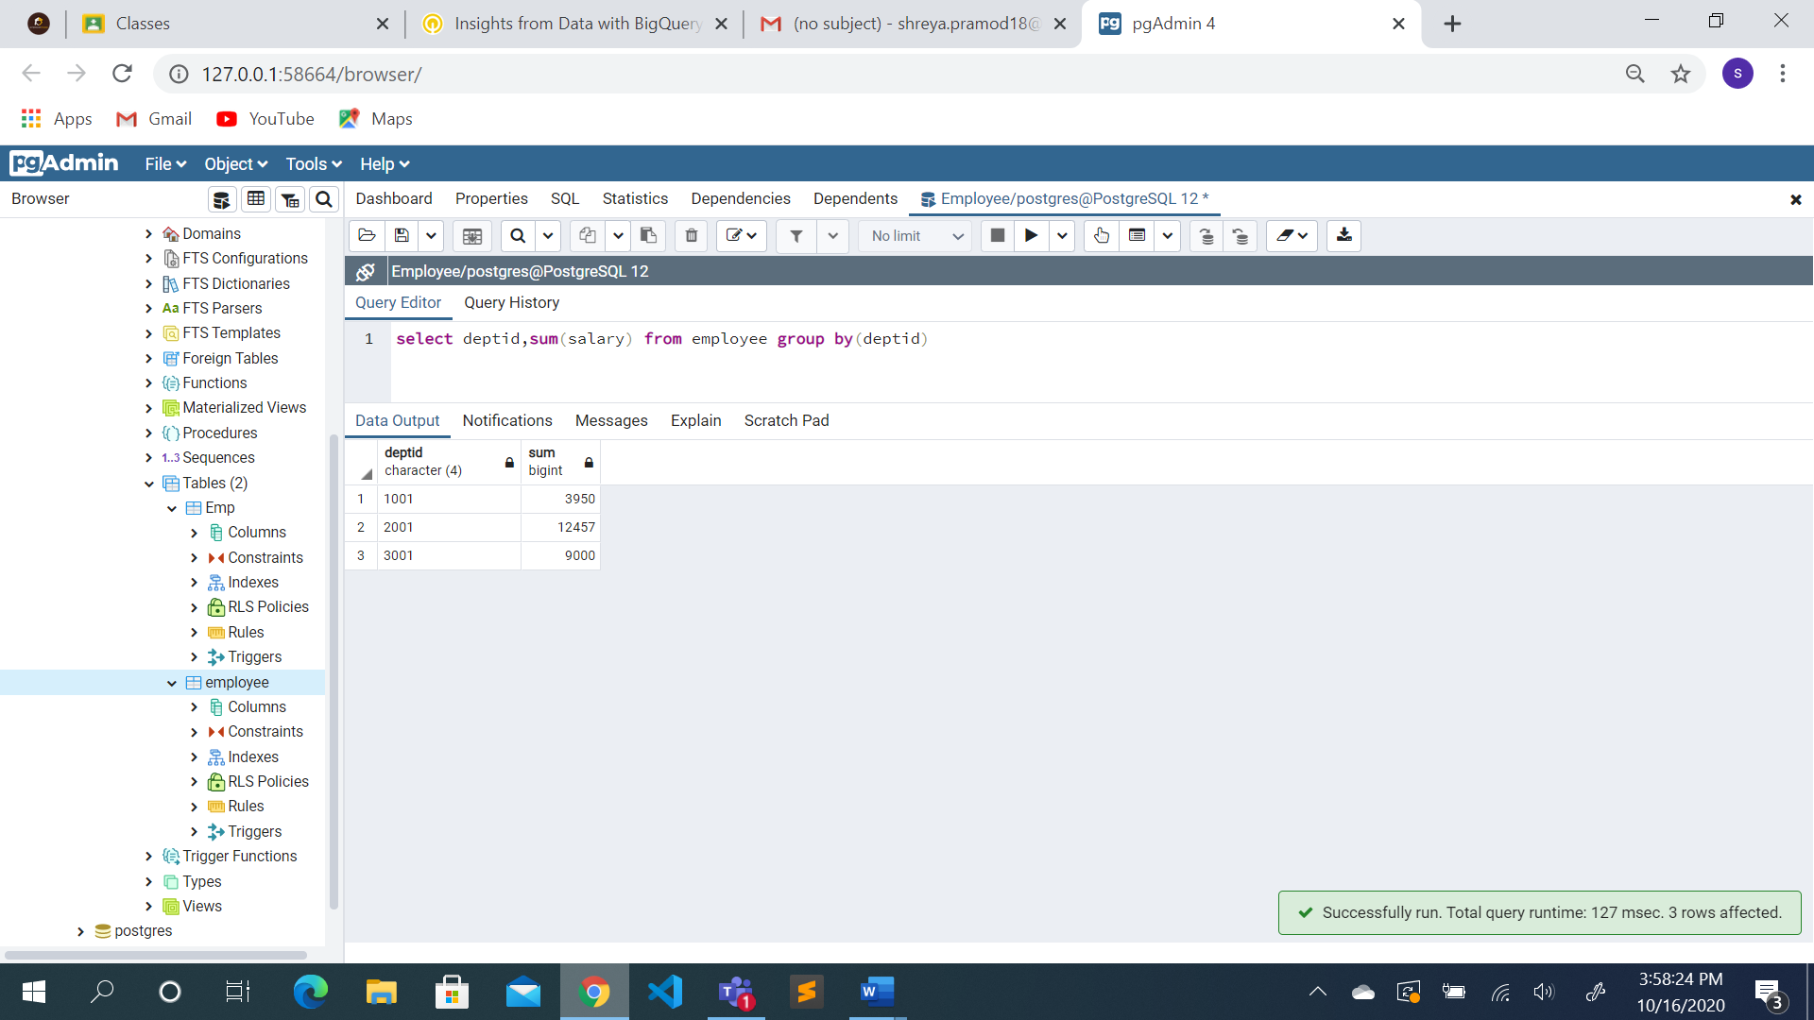

1. Get the total salary for each job.

**select job_name,sum(salary) from employee group by(job_name)**

